班級: BK 3
日期: 12/11/2016
名字:

床前明月光  疑是地上霜  舉頭望明月  低頭思故鄉 | 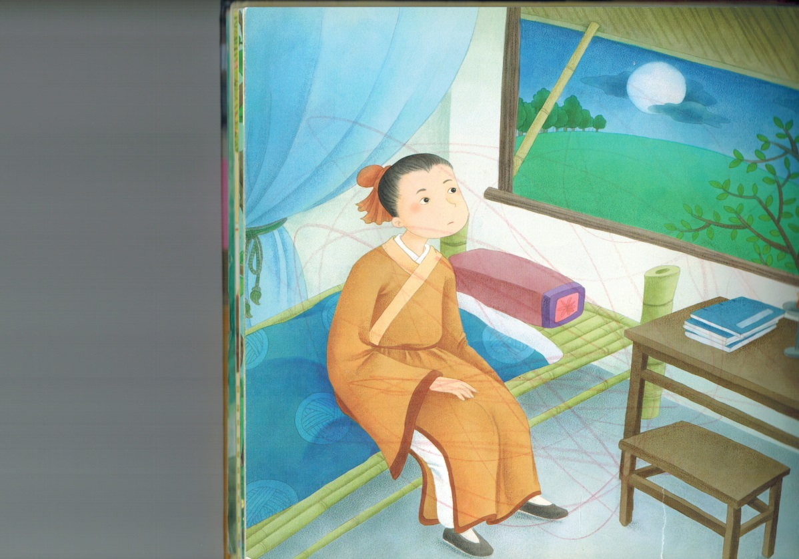

Please check (V) below after you have read each day
Mon | Tue | Wed | Thu | Fri | Sat

